Review Meeting- 052
Gaurang Garg
BioPhotonica Lab, Centre for Biomedical Engineering, IIT Delhi
2024-10-01 (Tuesday)
Title: Centimeter scale 3D imaging via multislice approach
Abstract: High throughput 3D Imaging for various applications requires higher value of SBP as wide FOV with high resolution. Lens-less maskless on-chip imaging framework has been able to achieve centimeter scale reconstruction with good resolution. 3D Imaging can be extended to the framework by modelling the sample based on multi-slice approach and implementing light-field refocusing as the guess estimate. Proposed theory could enable simple, fast 3D imaging with HR.

1. Introduction
The inherent trade-off between FOV and resolution as quantified through space-bandwidth product can be resolved through computational framework involving minimal hardware complexities; even as to achieve centimeter scale FOV ($2.7 × 1.7 {cm}^{2}$) with a resolution of $1.38 μm$ equivalent to approx. 2.4 gigapixels phase images of transparent biological specimens [1]. The samples under consideration are thin on the ranges of few micrometers under approximations of 2D modelling [2], see Supplementary.

Supplementary

Thin Sample Approximation
The consideration of a sample whether it is thin and can be considered 2D is based on optical system’s Depth of Field (DOF). The 2D approximation holds if the thickness of the sample is less than or approximately equal to system’s DOF. Under this assumed region, the light rays do not significantly diffract or spread laterally while propagating through the sample. Within these bounds, entire physical volume can be modelled as a compressed infinitely thin 2D complex transmittance plane. This at plane of focus is equivalent to pure phase transmittance with no amplitude modulation. Amplitude fluctuations only arise due to defocus after the light exits the sample and propagates through the air gap to the sensor.
In the on-chip framework [1,2], the researchers successfully utilized the 2D approximation to reconstruct 10 µm diameter microspheres , 12 µm thick zebrafish sections , and 16 µm thick mouse kidney sections.
Out of bounds of DOF, the 2D approximation physically breaks down. In thick samples, the light rays from different illumination angles take different paths across the sample. The light internally gets diffracted internally before exiting the sample. Because of path-dependency, angled data represents tomographic information. For accurate reconstruction the sample must be modelled as to account for internal scattering and diffraction effects, such as the multi-slice model, which splits the volume into a series of N thin slices. The wave field propagates from slice to slice, with each layer modulating the field sequentially.
In the multi-slice Fourier Ptychography framework [3], the researchers imaged an algae sample with a total thickness of 100 µm. They computationally sectioned it into 11 slices separated by 10 µm each to accurately recover the 3D intensity and phase.

Depth of Field
To know the physical range of 2D approximation and allowed sample thickness, we must calculate system’s axial resolution. For a lens-less system like the on-chip framework, the effective Numerical Aperture and thus the axial resolution is determined by the gap between the sample and sensor and physical parameters of the sensor. The geometric Numerical Aperture (NA) is dictated by how much of the scattered light the sensor can physically intercept. It is dependent on the maximum angle subtended between the sample and the edges of the sensor, which is equivalent to light gathering in conventional lens-based system [1,2].
$$NA = n∙\sin{φ = \frac{W}{2\sqrt{{∆z}^{2}+ {W^{2}}/4 }}}$$
Where n is the refractive index of medium between the sample and sensor and W is the sensor width.
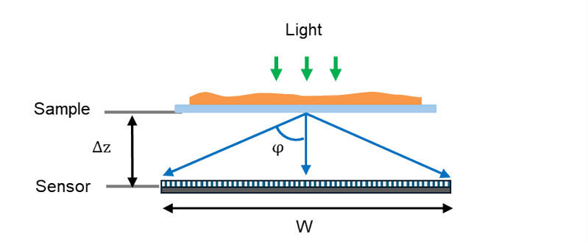
Figure 1 Effective NA of the on-chip system [2]
Given $W=7.4\text{ mm}$ and $Δz=1\text{ mm}$, and medium being air (n = 1) the theoretical effective $NA = 0.94$. Using standard formulas and wavelength ($λ = 632nm$), the DOF of the system comes out as,
$$DOF ≈ \frac{λ}{{NA}^{2}} ≈ 0.71 μm$$
Thus, any sample thicker than this value must be considered 3D volume. But, the authors reconstructed samples in the ranges that are not sub-micron successfully using 2D approximations [1] (10 µm diameter microspheres , 12 µm thick zebrafish sections , and 16 µm thick mouse kidney sections).
The system’s practical DOF is constrained by camera’s pixel pitch. The pixel size acts as a low-pass filter, limiting the practical resolution. According to the Nyquist-Shannon sampling theorem, the smallest feature you can resolve is twice the pixel pitch [4,5]. For the pixel pitch as $1.85 μm$, the smallest resolvable feature is $3.7 μm$. The practical limited NA corresponding to this physical resolution is,
$${NA}_{practical} = \frac{λ}{resolution} ≈ 0.17$$
The practical DOF can be calculated using this NA comes out as $21.8 μm$. If the sample is in ranges of this limit, it can be approximated as thin.

